ANIMAL TRACKING BEYOND SAFE ZONE USING RF PROTOCOL

Abstract
The objective of this project is for confining the movement of animals, and particularly to apparatus for limiting the range of movement of an animal to a space within a defined boundary. By this if the animal moves beyond the limit and enters the new zone, a siren alert is given to the guard. So that they can identify the animal as it approaches the perimeter of the prescribed area. One sort of apparatus for this approach includes a radio frequency transmitter and a radio frequency receiver. A RF transmitter is always carried by the animal, transmitting its ID code continuously, while few RF receivers are kept around exit zone or unsafe zone. When the animals are in its safe zone, the security system is quit. If any of the animal exits the safe zone and reaches the next layer of safe zone (i.e., the RF monitored zone), the RF receiver present at the monitored zone detects the ID code of the animal trying to escape from the safe zone and gives an siren alert along with the animals detail.
Powerful 8 bit Microcontrollers are used for this purpose. It holds the detail of all animals which are tagged under observation. By this the wild animals can be cached easily before entering humans’ colony avoiding huge dangers.

BLOCK DIAGRAM
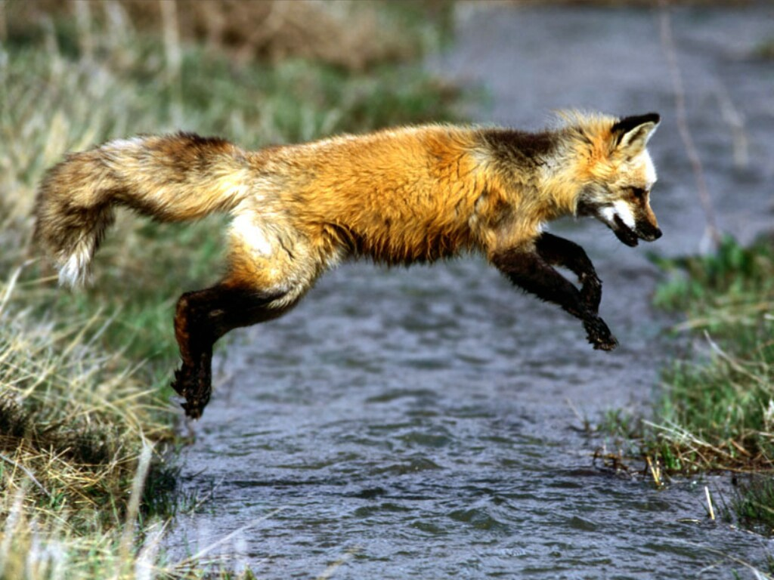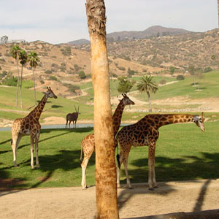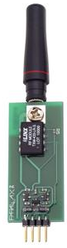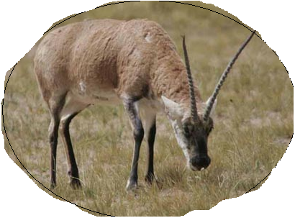
UNSAFE ZONE - I

UNSAFE ZONE - II

ANIMAL SAFE ZONE
ANIMALS WITH RF TRANSMITTER
MICROCONTROLLER

LCD

DRIVER
MICROCONTROLLER

LCD

DRIVER

